**Phase 5: Apex Programming**

**Objective:**

The objective of this phase was to implement complex, custom business logic using Apex for requirements that could not be met with declarative tools. This involved writing an Apex Trigger to handle a specific business rule for case prioritization.

**Completed Actions:**

* **Apex Trigger Creation:** An Apex Trigger named **CasePriorityTrigger** was developed on the Case object. This trigger automatically fires before a new case is saved and checks if the Case Sub-Category is "Transaction Dispute". If it is, the trigger sets the Priority of the case to "High", ensuring that these critical cases are flagged immediately.
* 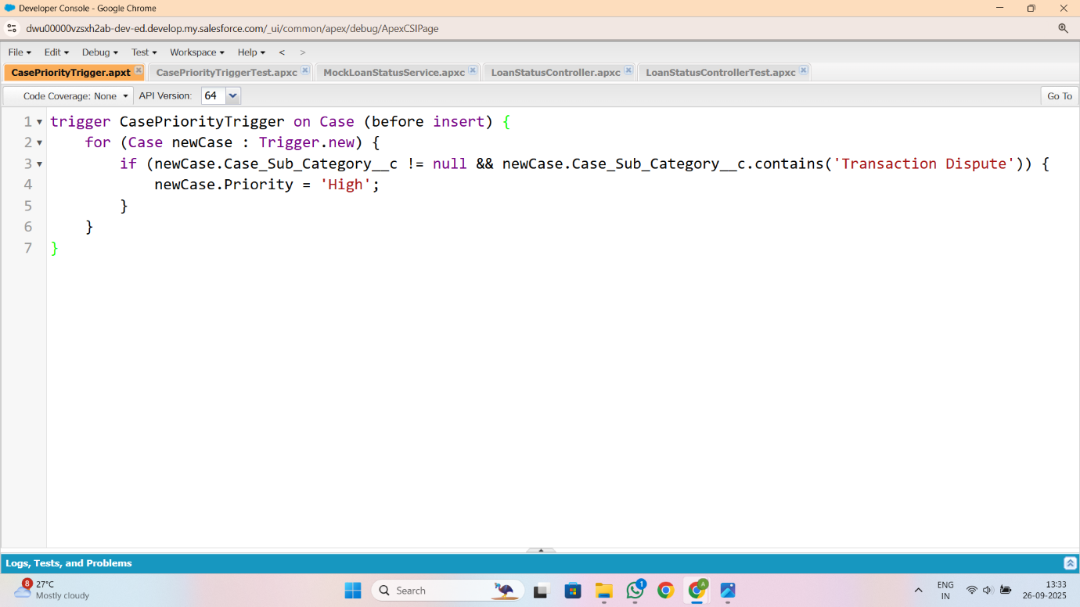**Apex Test Class:** A corresponding test class, **CasePriorityTriggerTest**, was created to verify the trigger's functionality. The test class creates a sample "Transaction Dispute" case, inserts it into the database, and then asserts that its priority was correctly set to "High". This test ensures the trigger works as expected and achieves 100% code coverage, which is mandatory for deploying Apex code to a production environment.

